LAB ASSIGNMENT – 8
UNSTRUCTURED DATABASE LAB
SAZIDUR RAHAMAN, UG/SOET/165/24/001

Q1. Display all flights.

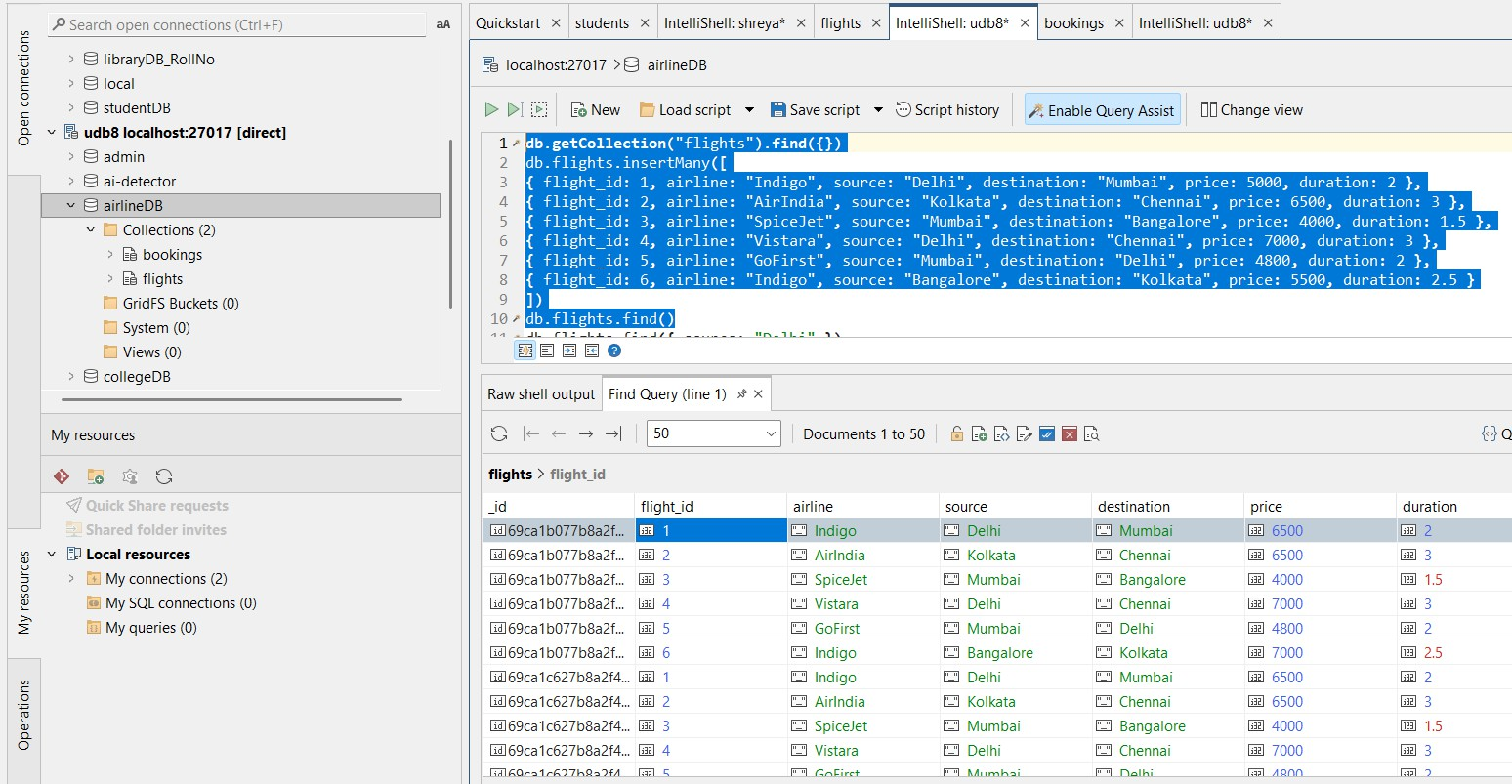

Q2. Display passenger_name and city from bookings.

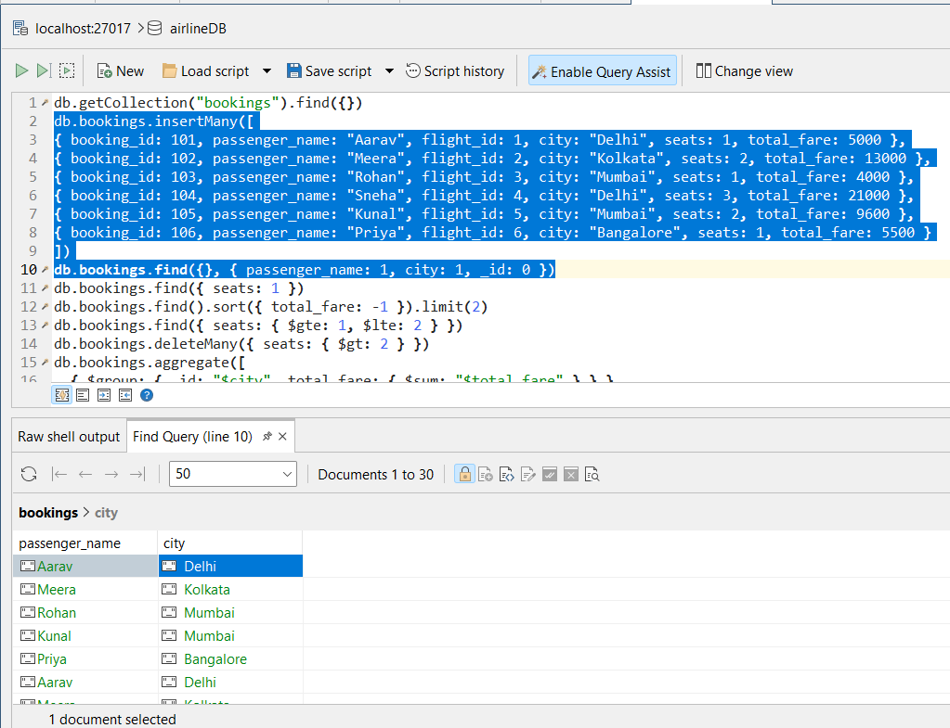

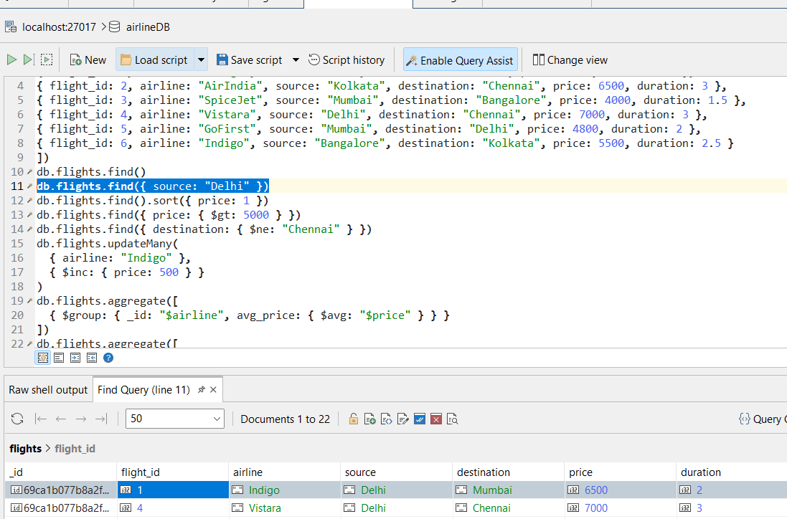
Q3. Find flights where source is Delhi.

Q4. Find bookings where seats = 1.

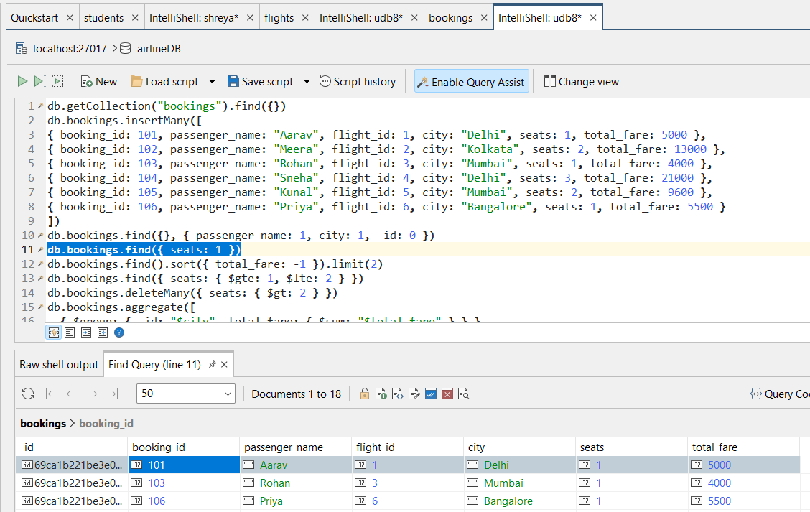

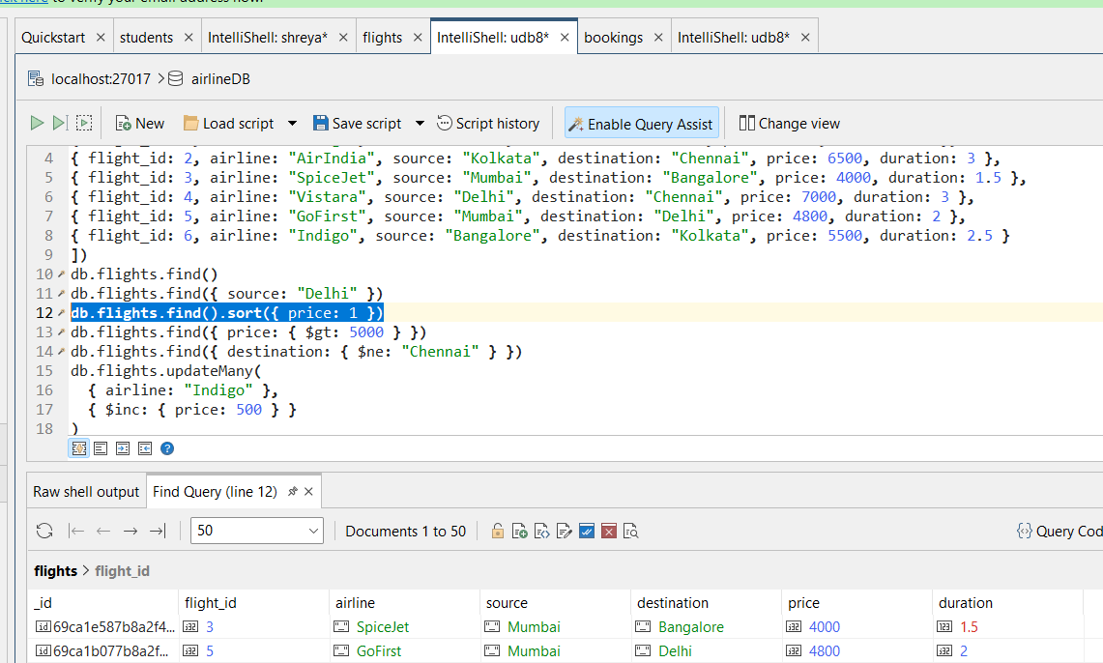
Q5. Sort flights by price in ascending order.

Q6. Display top 2 bookings with highest total_fare.

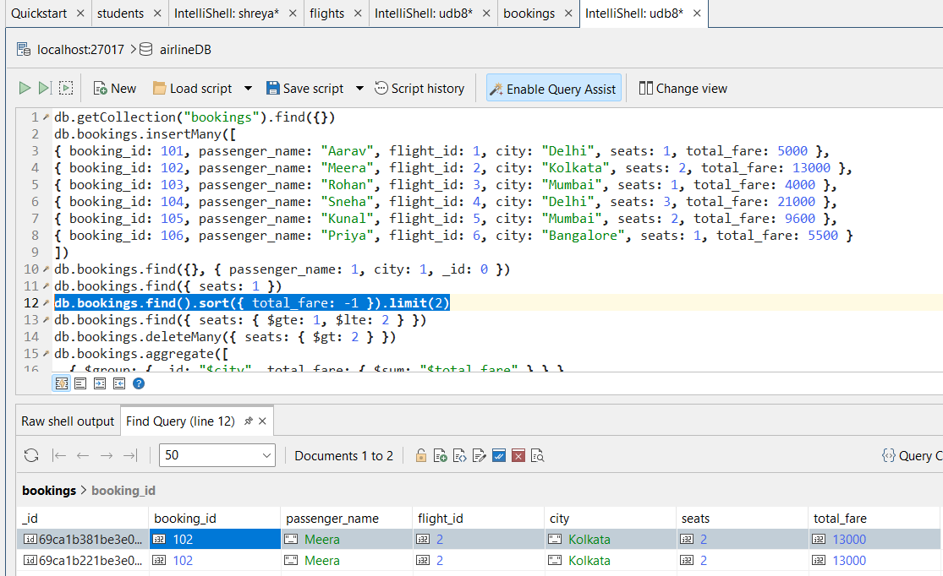

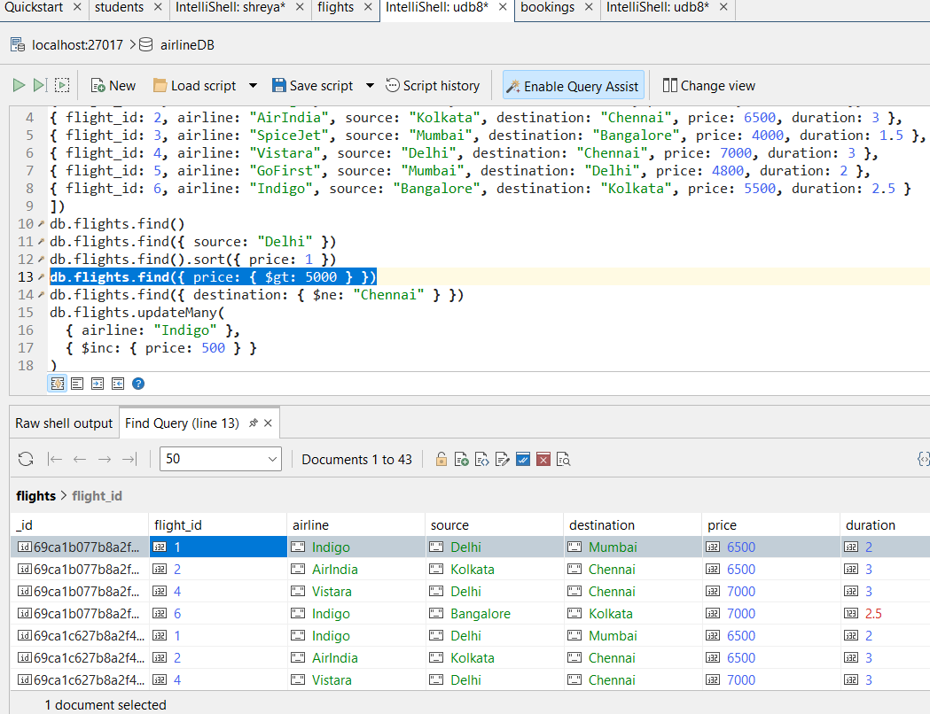
Q7. Find flights where price is greater than 5000.

Q8. Display flights where destination is not Chennai.

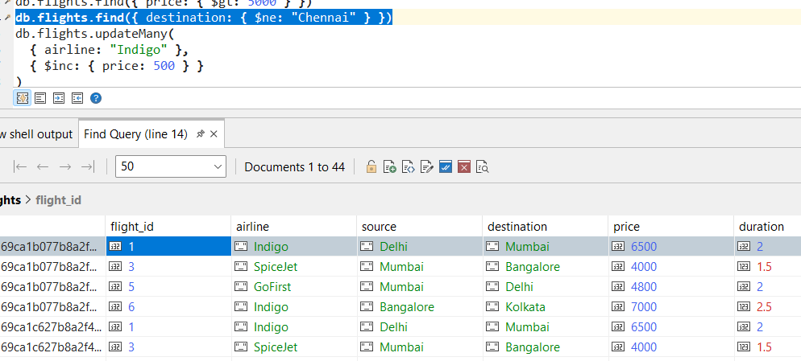

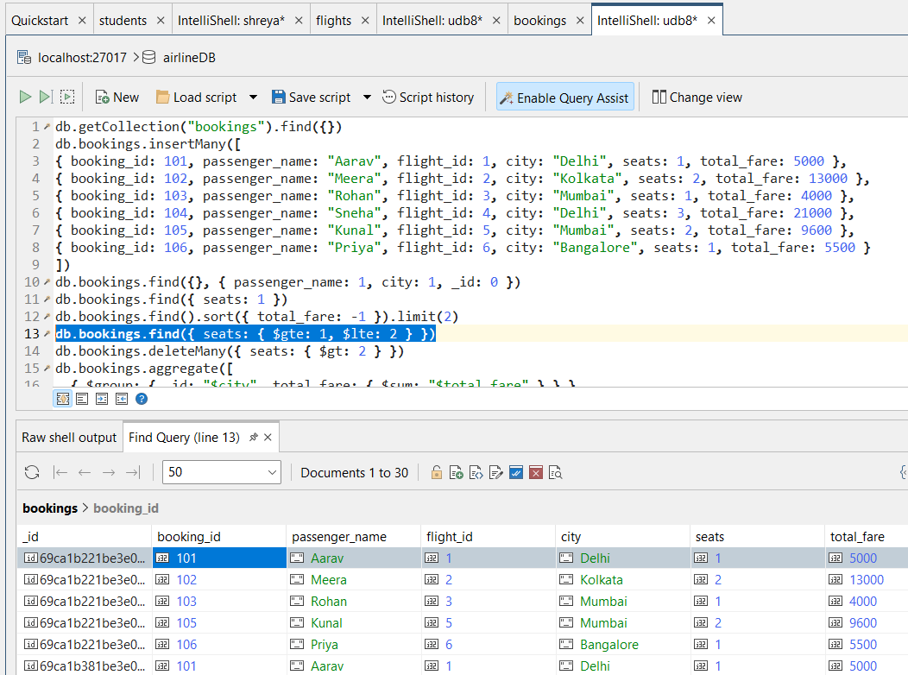
Q9. Find bookings where seats are between 1 and 2.

Q10. Update price by +500 for flights of airline "Indigo".

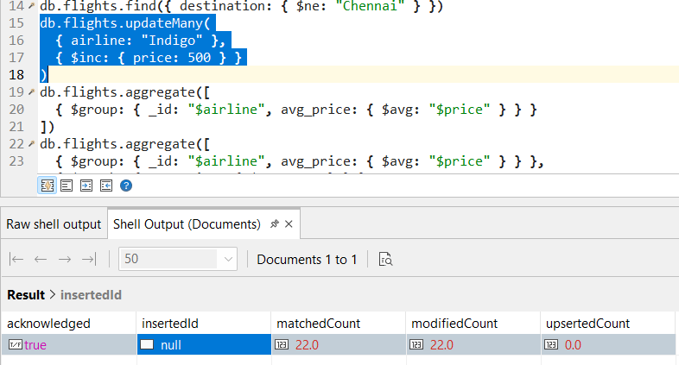

Q11. Delete bookings where seats are greater than 2.
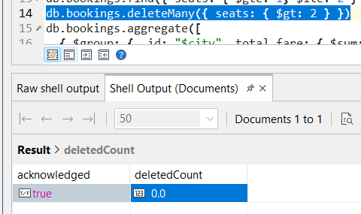

Q12. Find total fare collected city-wise. (Aggregation)

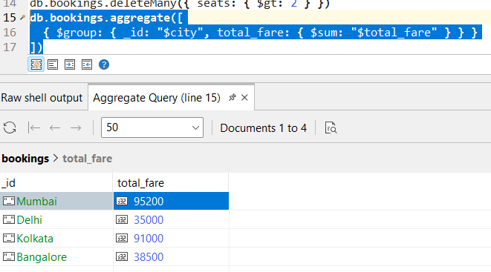

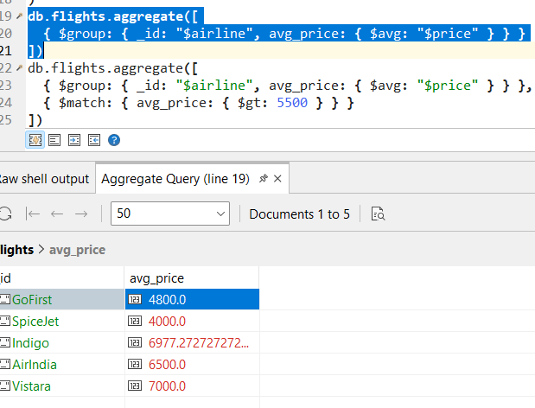
Q13. Find average flight price per airline. (Aggregation)

Q14. Display airlines where average price is greater than 5500. (Aggregation + filter)

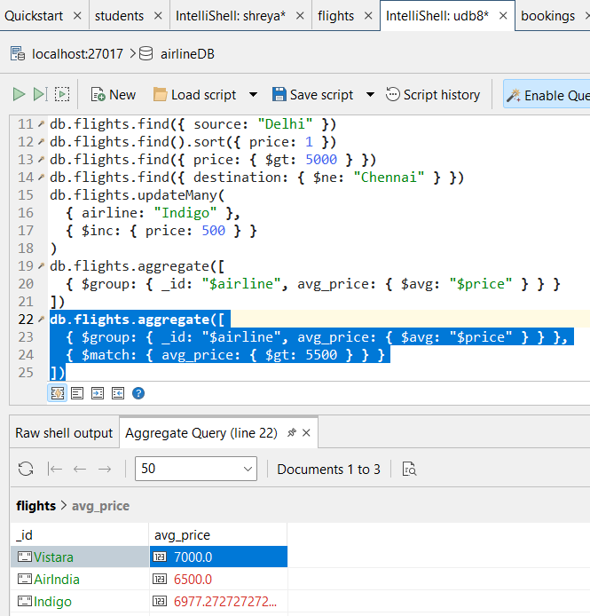

Q15. Find maximum total_fare among bookings for each city. (Aggregation)

